Session 02 - Lab Assignment: Keylogger Wei Cui

Lab Objective:

1. Follow the instructions for Project 2-4: Use a Software Keylogger.
2. Write a report including screenshots and written descriptions. Be sure to include a screenshot and description for step 28.

Lab Results:

* Installed Spyrix
* Created new online monitoring account
* Set Delivery Interval to 2 minutes
* Used my computer as normal for several minutes. Spyrix recorded my usage activities and sent to online monitoring account as shown below.

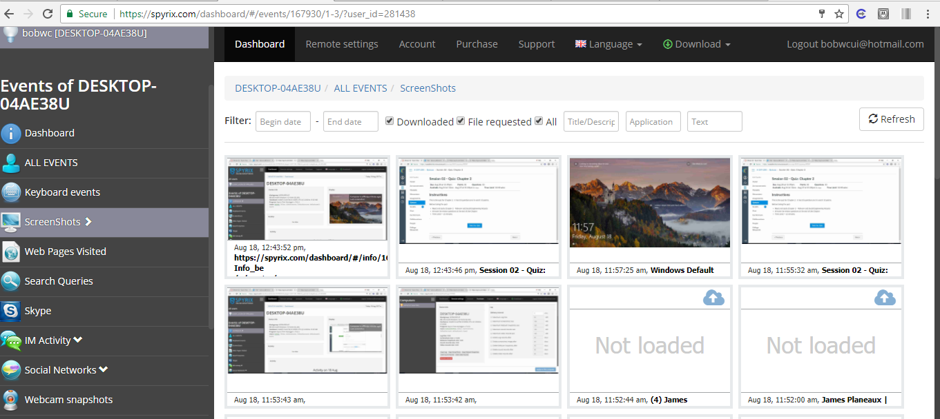

URL to Spyrix Dashboard

Screenshots of the desktop that has Spyrix installed

Fig. 1. Screenshots of the screenshots of the desktop that has Spyrix installed. The screenshots are sent to Spyrix dashboard online every two minutes.